**Note:** Only classes A,B,C of IPv4 can be assigned to devices.D and E classes have special purposes.

**Question:** How does a company get their own network to use.

**Answer:** IP addresses are assigned to companies or organizations by a non-profit American corporation called the IANA(Internet Assigned Numbers Authority).

**Note:** The IANA assigns IPV4 addresses/networks to companies based on their size.

**Note:** For example,a very large company might receive a class A or class B network(because there are lots of available addresses to use for hosts in each class A and class B network),while a small company might receive a class C network(because there are fewer addresses in each class C network,only 256).

**Note:**  However,this lead to many wasted IP addresses ,so multiple methods of improving this system have been created.

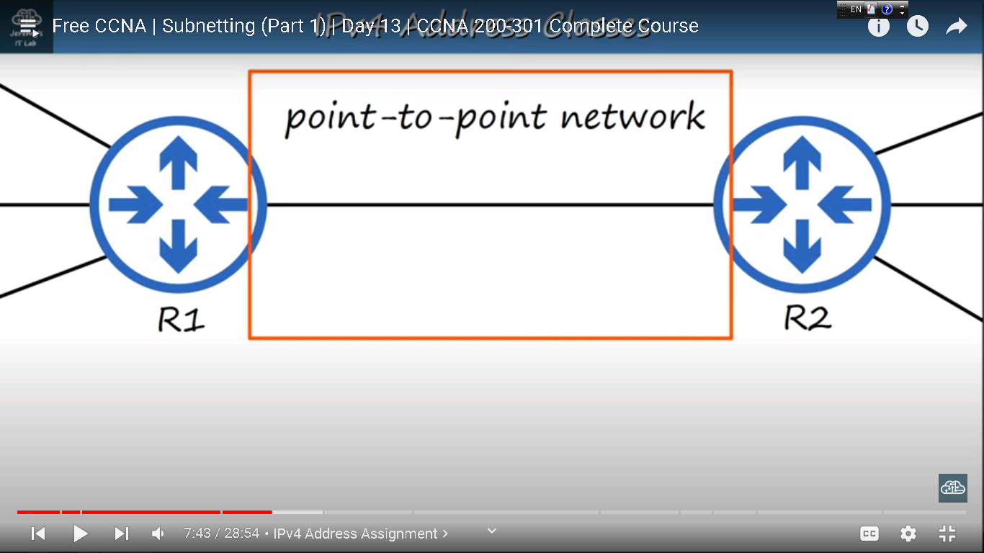

**Explanation of wasted IP addresses**

**Note:** These two router each have three different networks connected to them.However,there is one more network there.That’s the network connecting these two routers.This is known as a **‘point-to-point’** network,meaning that it’s a network connecting two points,in this case R1 and R2.For example this might be a connection between offices in different cities,let’s say San Francisco and New York.Because this is a point-to-ppoint network we don’t need a large address block,so we use a class C network.So here is that network with 254 wasted IP addresses and used IP addresses(on the image below).

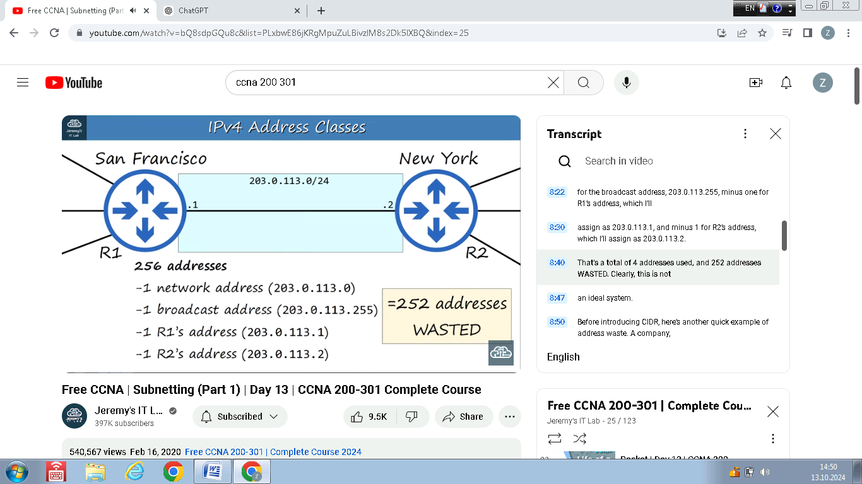

**Example of wasted classes**

**Note:** The total IPv4 address space includes over 4 billion addresses(232 ),and that seemed like a huge number,but now address space exhaustion is a big problem,there’s not enough addresses.One way to solve this problem is **CIDR.**

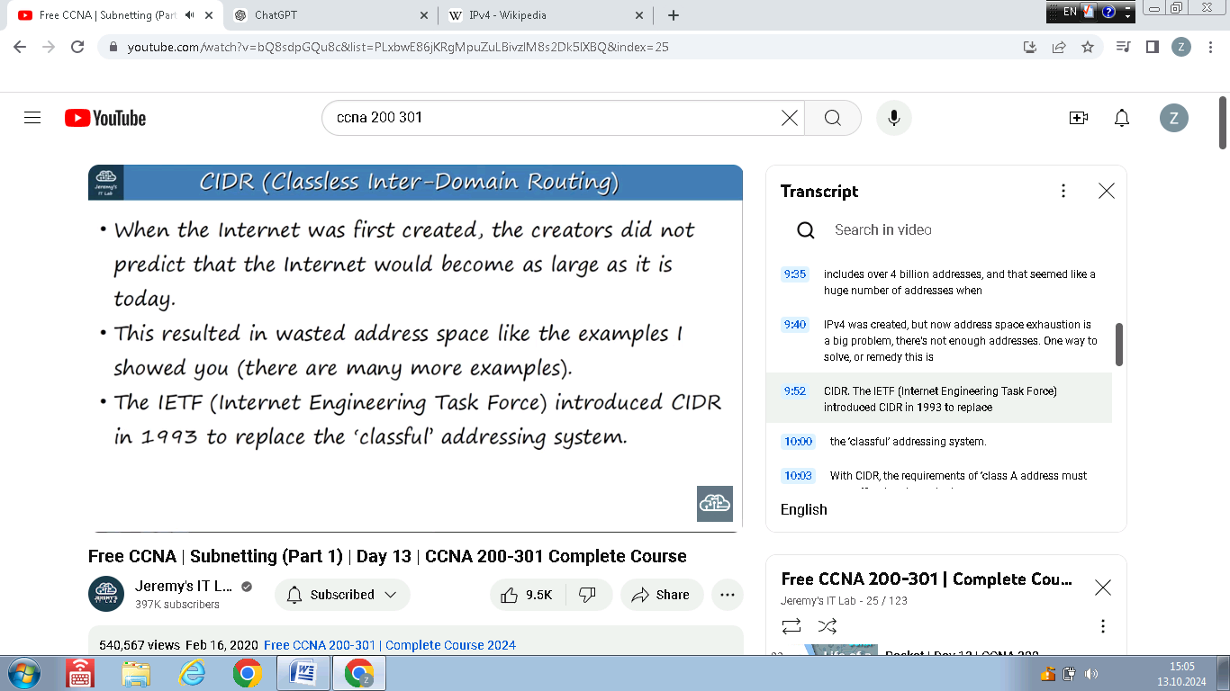

**CIDR(Classless inter-domain routing)**

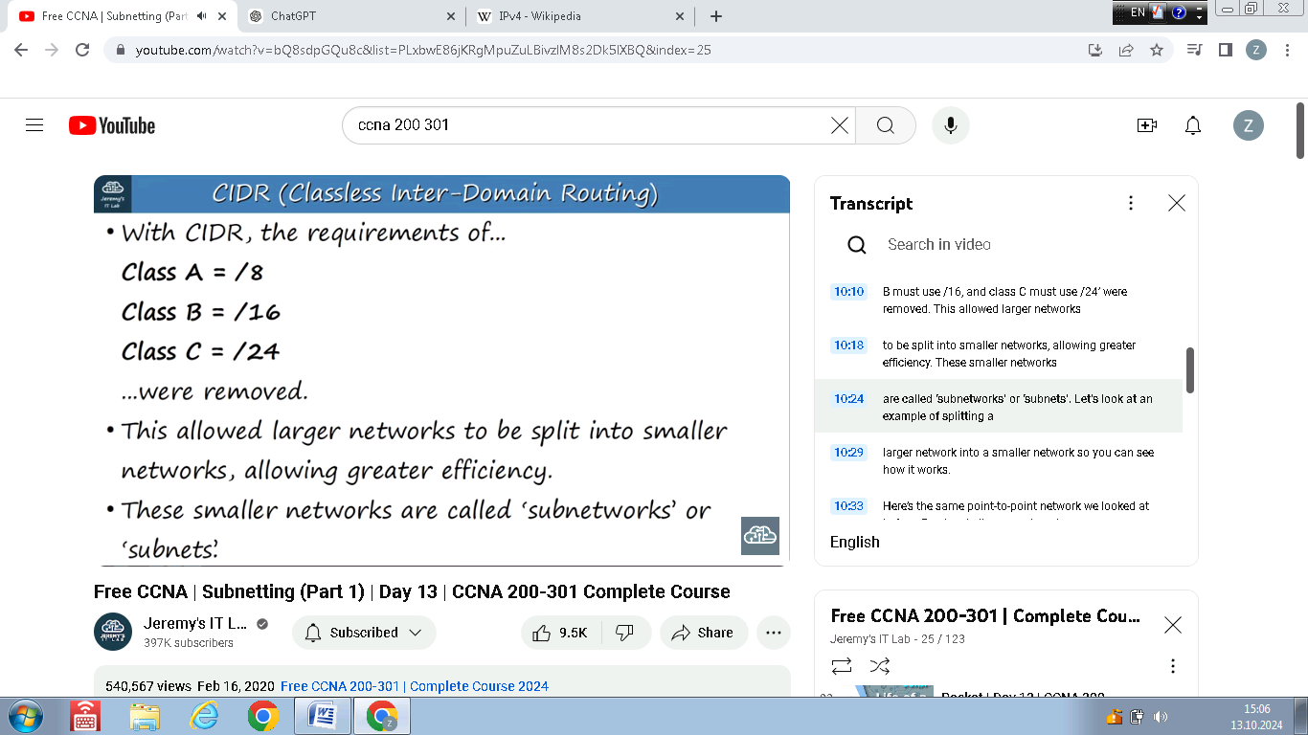

**CIDR and Subnets**

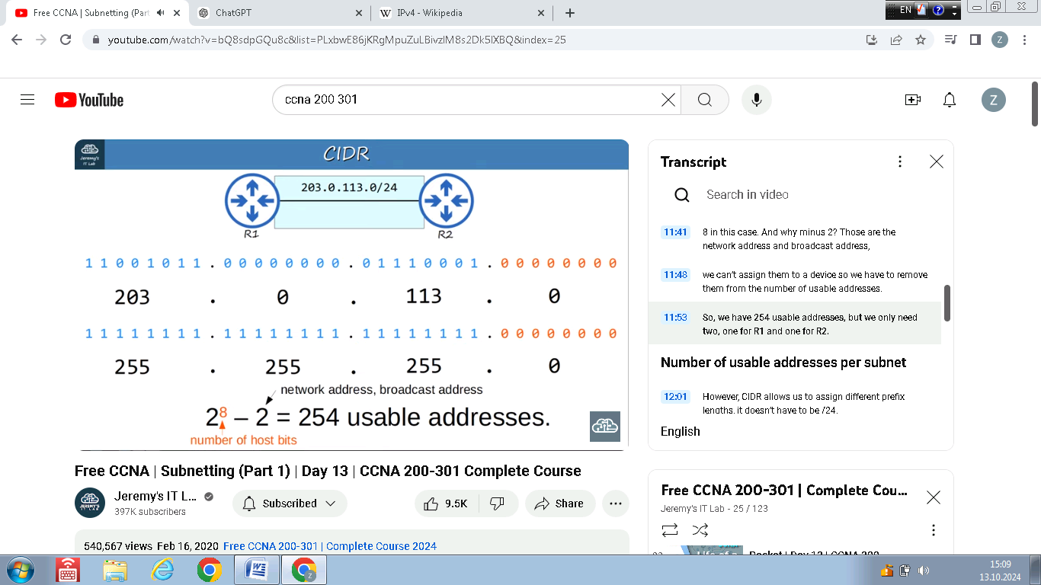

**The same point-to-point network from example above**

**Note:** All 1’s in the **subnet mask(also known as netmask)** indicate that the same bit in the address is the network portion.

**Note:**  We have 254 usable addresses but we use only 2 of them.

**Note:** However,**CIDR** allows us to assign different prefix lengths,so it doesn’t have to be for ex. /24.

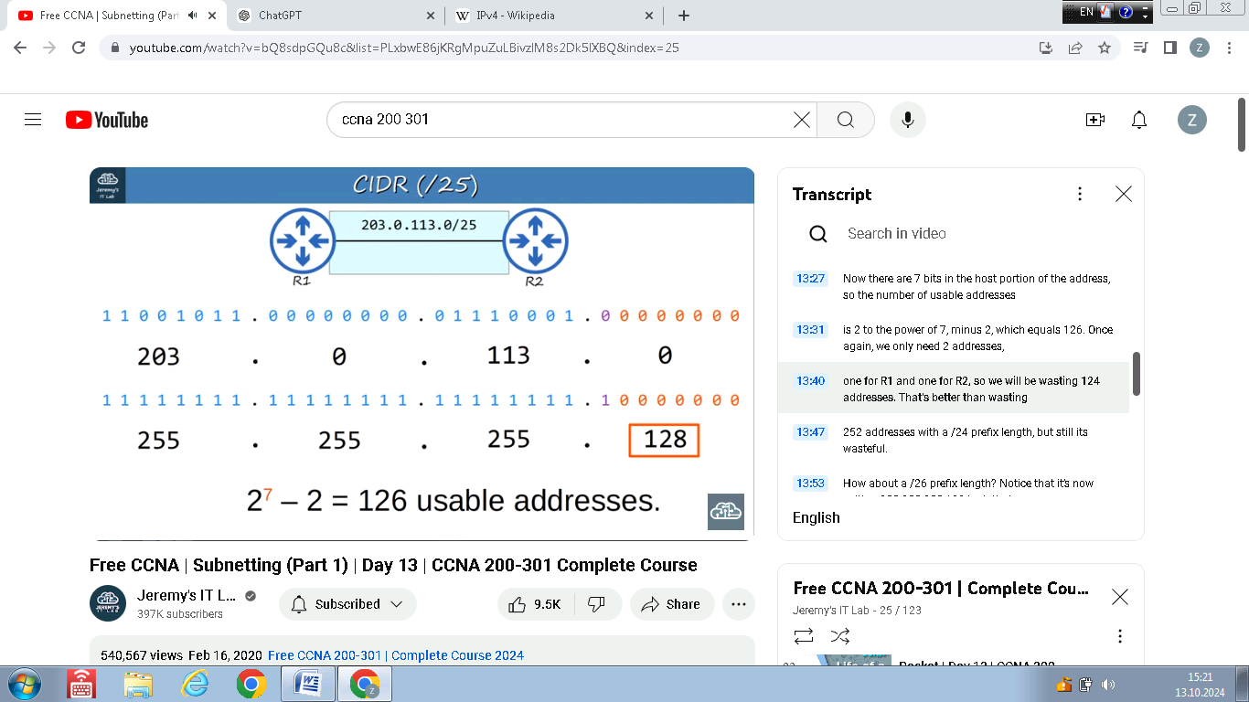

**Using /25 prefix length**

**Note:** In this case second row is the **subnet mask**(in dotted decimal version it is 255.255.255.128).

**Note:** Purple part(purple digit) in **subnet mask** is also the network portion.So there are 7 bits in the host portion.

**Note:** When we use /25 prefix length,there is also 126 usable addresses,and we use only 2 of them,so we waste 124 addresses.So that’s better than wasting 252 addresses with /24 prefix length,but it’s still wasteful.

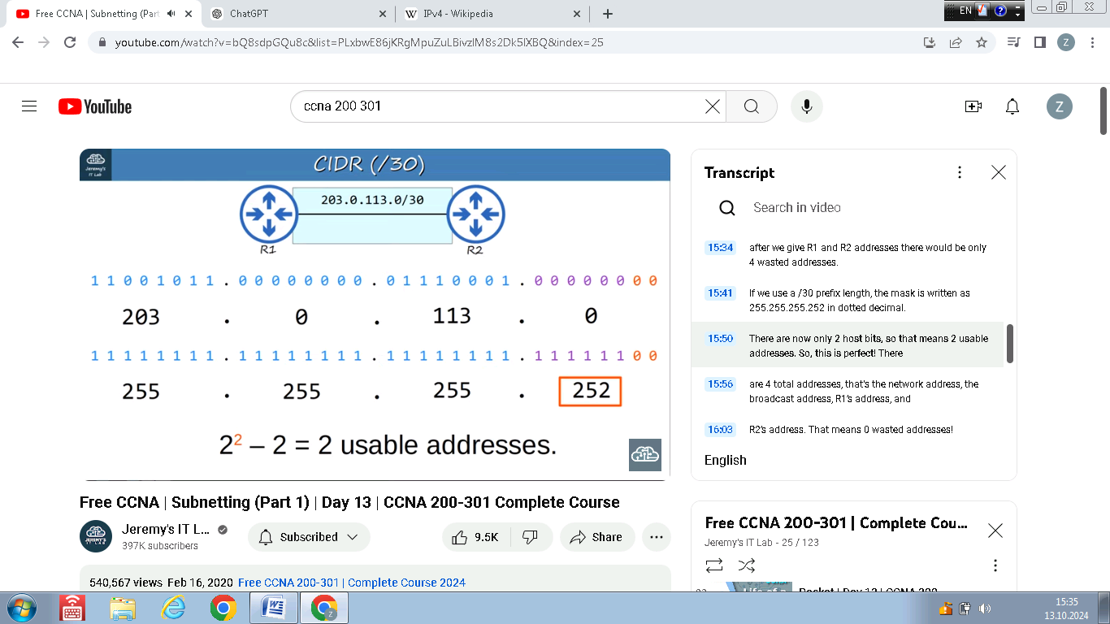

**Perfect prefix length for this network (/30 prefix length)**

**Note:** There are 2 usable addresses,because other 2 are network address and broadcast address.We assign 2 usable addresses to Routers and there are no wasted addresses.

**Note:** So,instead of 203.0.113.0/24,we will use 203.0.113.0/30,which is a **subnet** of that larger class C network 203.0.113.0/24.That **subnet** includes the address range of 203.0.113.0 through 203.0.113.3.

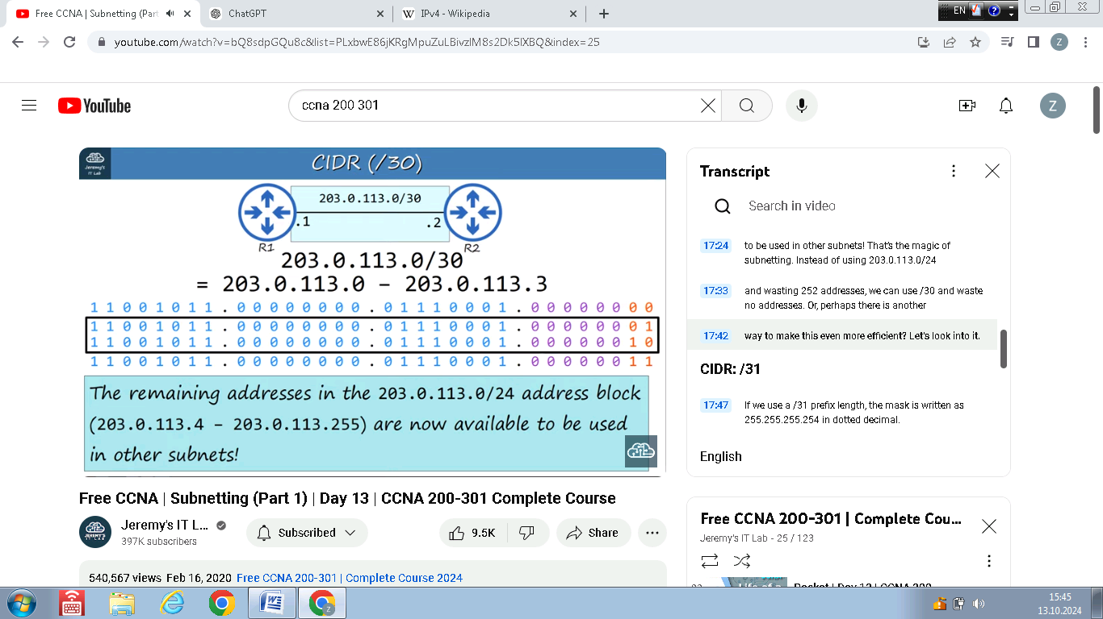

**About /30 prefix length**

**Note:** In box with two IP addresses(in binary) are two usable addresses when using /30 prefix length.

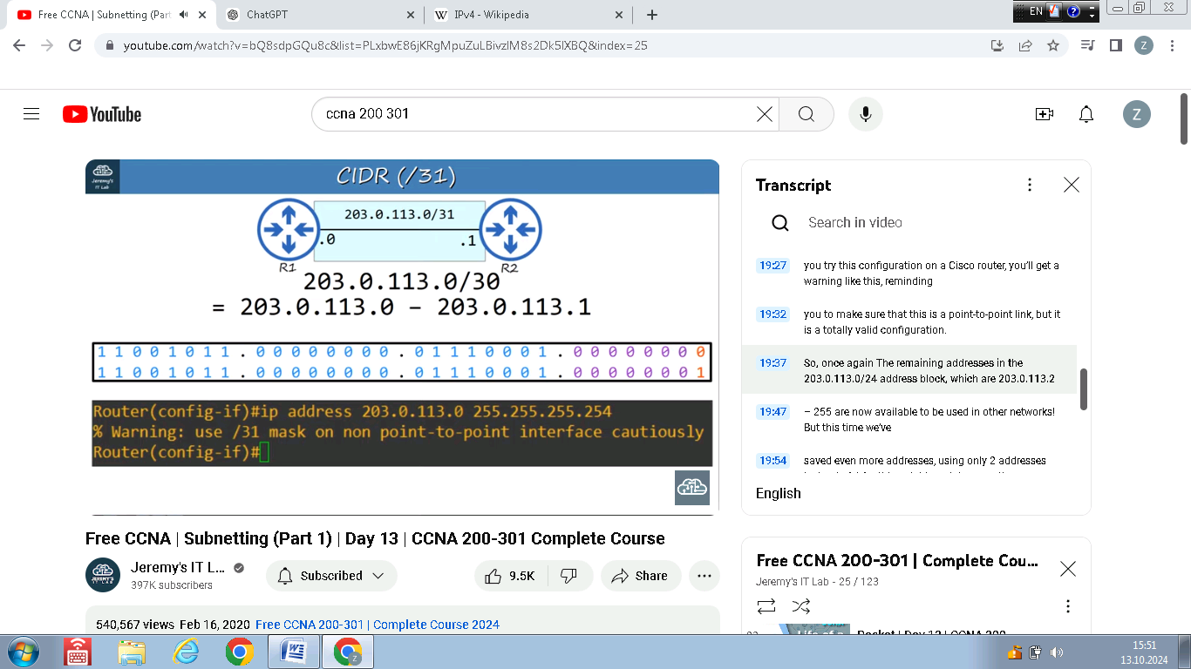**About using /31 prefix length**

**Note:** A network with /31 prefix length has only two IP addresses.**Normally it would be a problem because it leaves no usable addresses after subtracting the network and broadcast addresses ,but for point-to-point networks like this,a dedicated connection like this between two routers,there is actually no need for a network address or a broadcast address.So we can break the rules in this case and assign the only two addresses in the network to our routers.**

**Note:** On a cisco router we will get a warning like this ,reminding us to make sure that this is a point-to-point link,but it is a totally valid configuration.

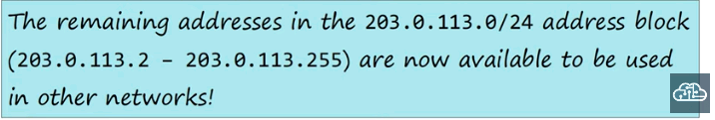

**Note:** This is even better than using /30 prefix length in previous network,because we’ve saved even more addresses,using only two addresses instead of using 4 in this **point-to-point connection.**

**Note:** People still use /30 prefix length,but /31 prefix length are totally valid and more efficient than /30 prefix length so it is recommended to use /31 prefix length.

About /32 netmask

**Note:** /32 netmask is never used to configure an actual interface

**Note:** There are some uses of /32 netmask,for example when we want to create static route not to a network,but just to one specific host,so we can use a /32 mask to specify that exact host.

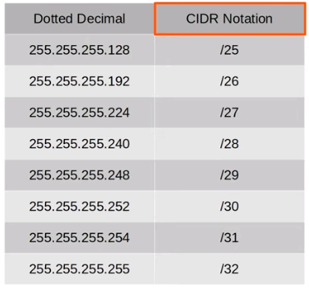

**Chart showing the dotted decimal subnet masks,and their equivalent in CIDR notation**

**Note:** In this chart /25,/26… etc are called **CIDR notation,**because it was introuduced with **CIDR system.**

**Note: So the use of subnetting is to divide a larger networks into smaller networks,called subnets.**

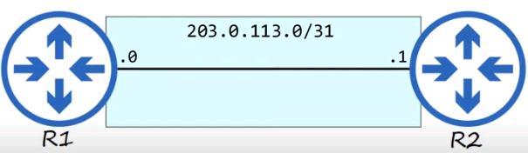

**Using /31 instead of /24**

**Note:** So instead of using the whole 203.0.113.0/24 network for the **point-to-point connection,**we can use a /30 subnet and use only 4 addresses,or even better use a /31 subnet and use only 2 addresses.

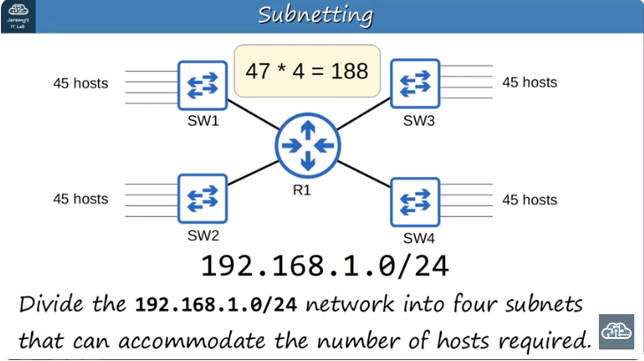

**Example of subnetting**

**Note:** There are 4 networks connected to R1.There are 45 hosts(including the IP address of R1’s interface) per switch.

**Note:** We have received the 192.168.1.0/24 network.And we must divide the network in the way it is written in text below the network topology.

**Note:** So we need 47 addresses per network(because we need also network address and broadcast address also).So we need totally 188 addresses.

**Note:** After checking the number of some prefix lengths,we find that best mask is /26 mask,because it has 62 usable addresses./26 is the best because /27 doesn’t provide enough space for 47 addresses.

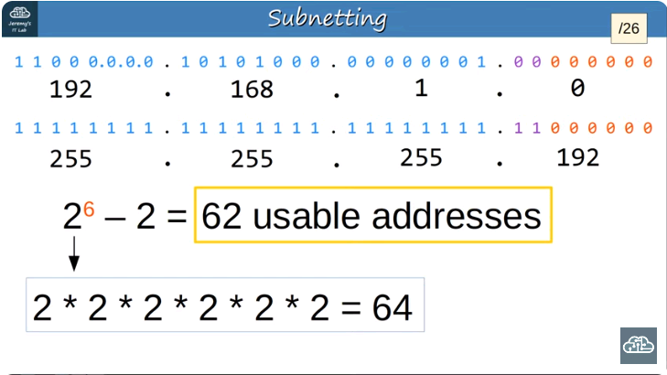

**Finding the best netmask(/26 netmask)**